Name: Mary-Rose Tracy
Date: 4/17/2025
Professor: Dr. Yonghe Liu
Class: CSE 4344-001
Lab 3 – Networking Tools
On your machine connected to the Internet, open a CMD window. I am assuming
that you are using a windows machine, but you can probably get all this to work on
any system. Open a text/word file so that you can save the results. In the CMD
window enter the following command:
ipconfig /all
Take a screen shot of the CMD window. You may need to scroll the window in order to
show all the information ipconfig displays. And paste the screen shot in the editor.
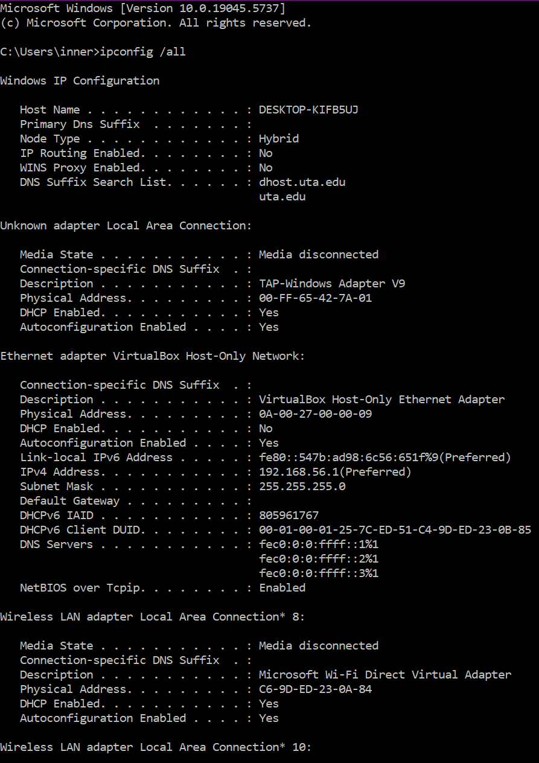
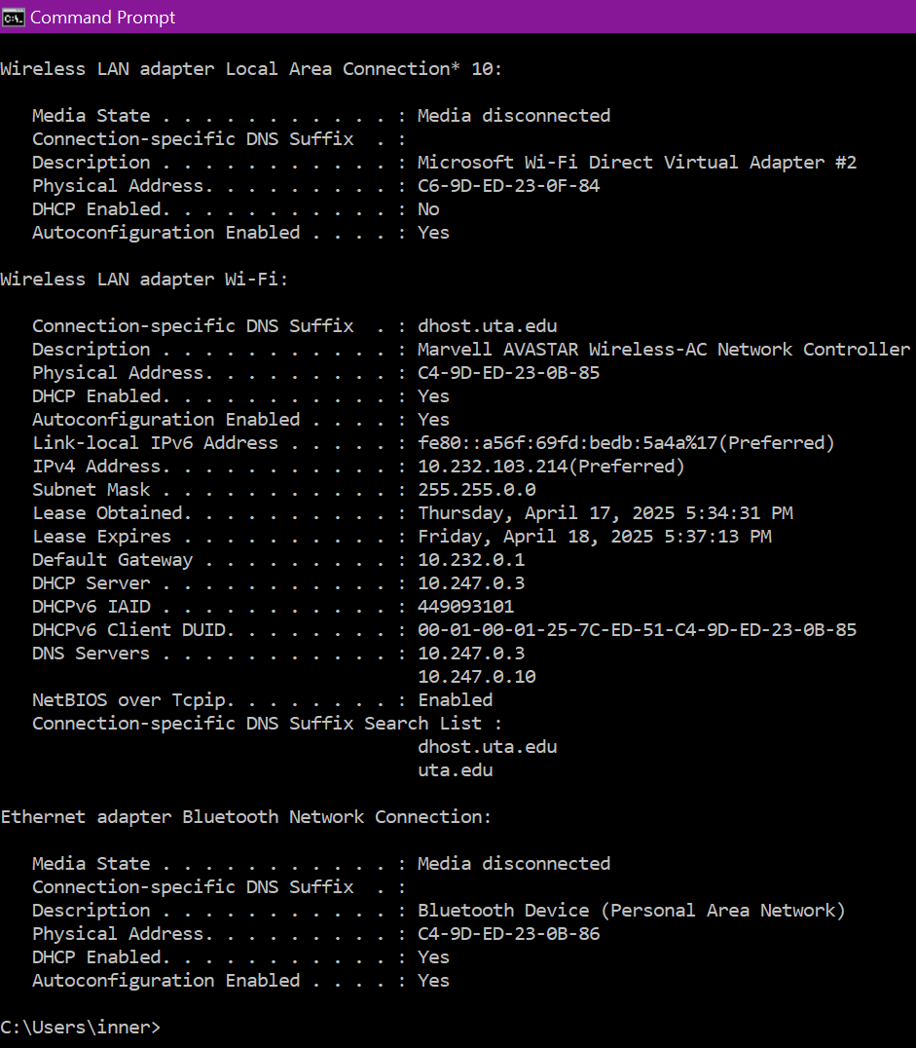
Answer the following questions.
▪ What is the IP address of this machine?
10.232.103.214 - This is the IPv4 address assigned to the Wi-Fi adapter, which is your main internet-connected interface.
▪ How did the machine obtain this IP address?
The IP address was assigned via Dynamic Host Configuration Protocol (AKA DHCP).
This is confirmed by the line (under the Wi-Fi section): “DHCP Enabled. . . : Yes.”
▪ What is the subnet part of the IP address?
Subnet: 10.232.103.0
The subnet mask is 255.255.0.0, meaning the first two octets (10.232) are the network portion. The subnet includes all addresses from 10.232.0.0 to 10.232.255.255.
▪ What is the MAC address of this machine?
C4-9D-ED-23-0B-85
This is the Physical Address listed for the Marvell AVASTAR Wireless-AC Network Controller, which is the Wi-Fi adapter.
▪ How did the NIC card obtain this MAC address?
The MAC address is hardcoded by the manufacturer into the NIC (Network Interface Card) during production. It's a unique identifier usually stored in the firmware.
▪ What are the DNS servers’ addresses?
This: 10.247.0.3
And This: 10.247.0.10
These are the DNS servers your network is configured to use. This is probably from the Universities wi-fi.
Now enter the following commands
ipconfig /renew
And then use Ipconfig /all to display the new configurations. Take a screen shot of the
CMD window and answer the following questions
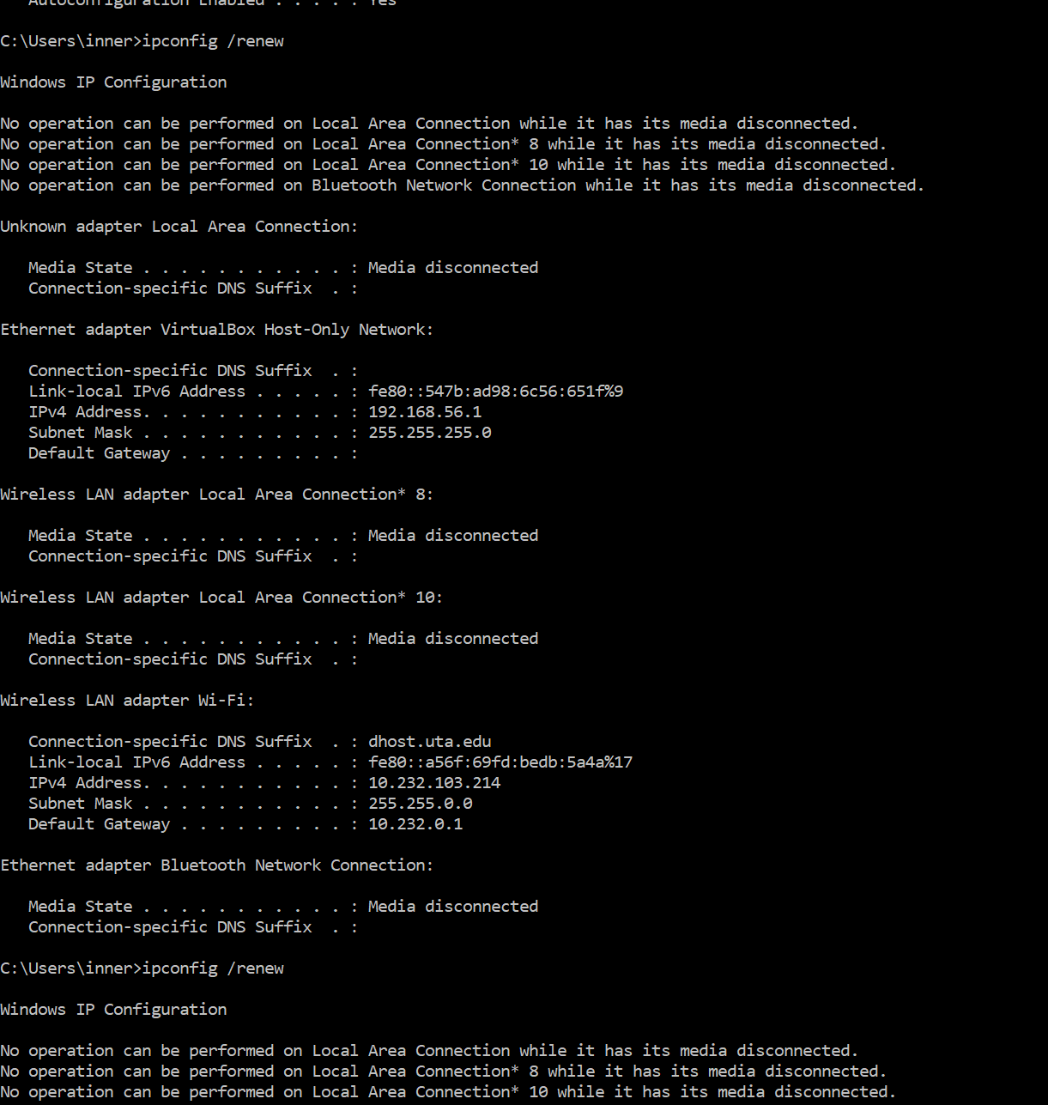
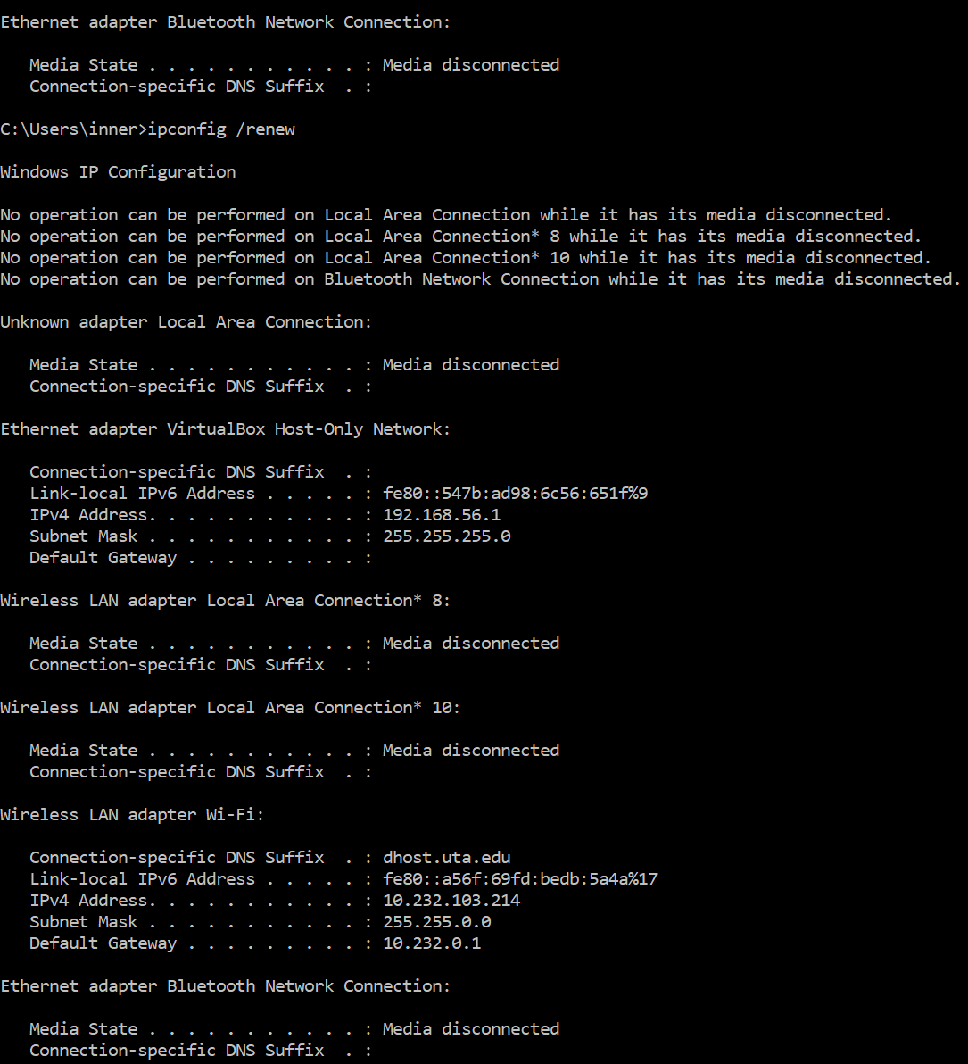
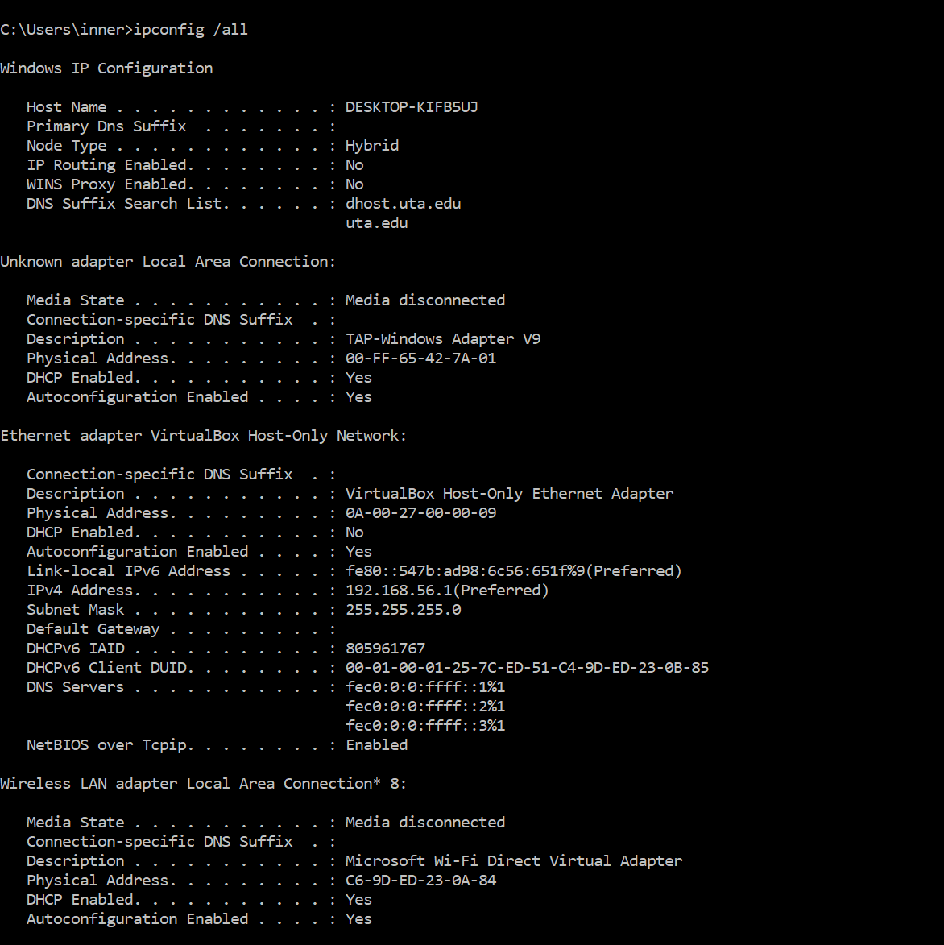
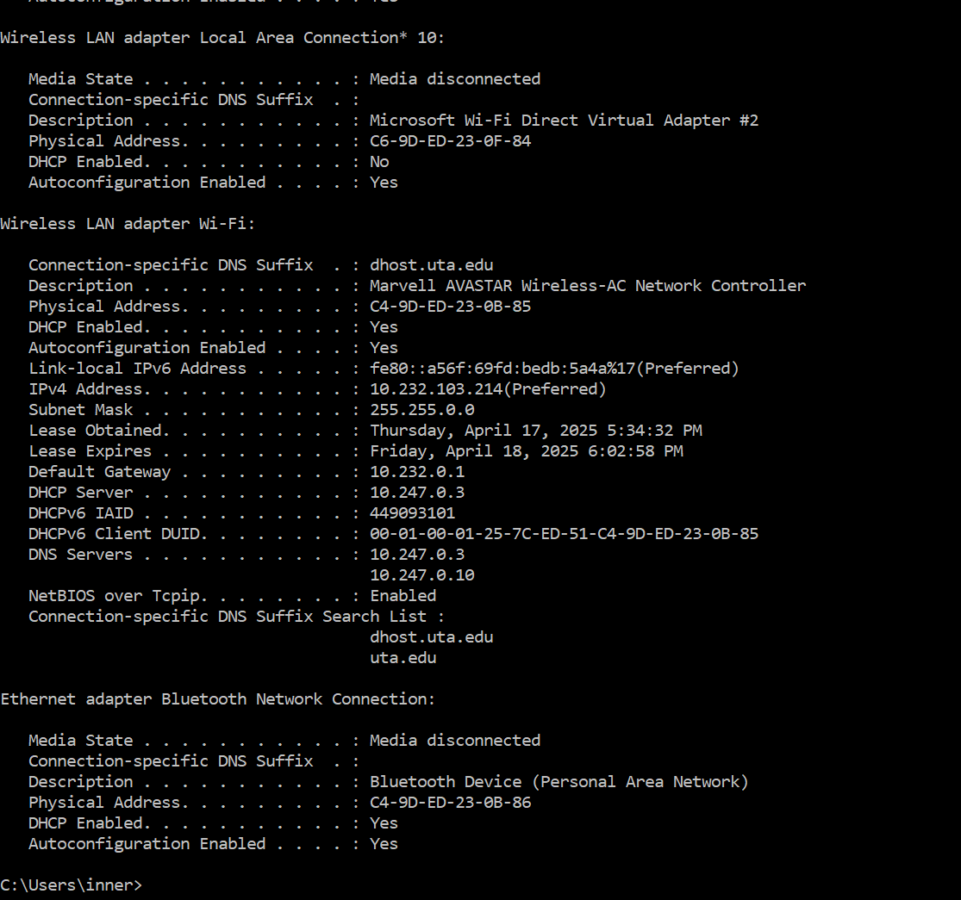
▪ What has changed as compared to the results of first run of ipconfig /all?
After running ipconfig /renew, the only change observed was the renewal of the DHCP lease, with updated "Lease Obtained" and "Lease Expires" timestamps, while all other network configurations (configs for short) stayed the same.
2. In the CMD window enter the following:
ping (your default gateway’s address from step 1, eg, ping 192.168.0.1)
Record the results in your text file with your favorite editor (you can use screen shot).
Ping is a very useful test for a networking person to quickly determine the status of much
of the network. What can you conclude from this simple test? Write your answer in the text file where you pasted the results of the command. There are quite a few things you
can conclude, so think about this for a few minutes. Envision ALL the steps in the process, starting with what the command says. List 3 things you can conclude from the
PING results.
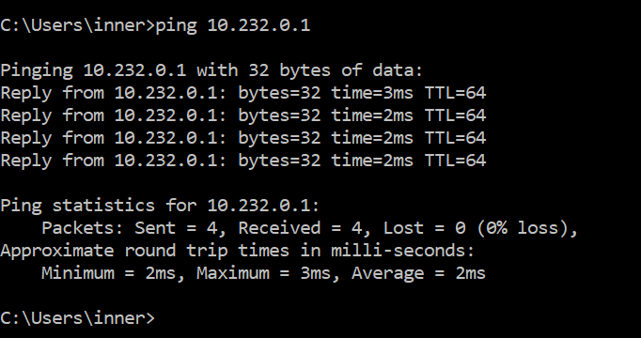
- My computer’s network adapter and IP setup seem to be working properly:
  - The fact that all 4 ping packets were successfully sent and received without any loss shows that my device is correctly connected to the local network and has a valid configuration.
- The default gateway (usually the router) is online and reachable.
  - Since I got replies from the gateway address, it means it’s up, functioning, and my computer is able to communicate with it over the network.
- The connection to the gateway is fast and stable.
  - The ping times (2–3 ms) are really low, and there was no packet loss, which means the connection between my PC and the router is both responsive and reliable.
3. In the CMD window enter the following:
ping www.utexas.edu The result should be different from step 2. Record the results of
this ping in your text file and save it to disk (you can use screen shot). Why did this
happen?
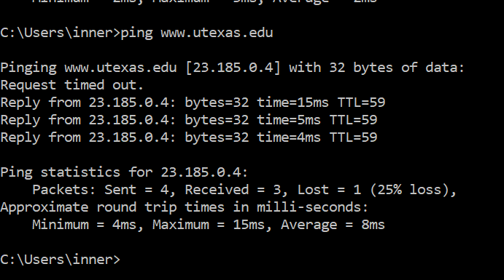

- The domain name had to be resolved through DNS before pinging.
  - Unlike the previous test that used a direct IP address, this one involved a domain name. The system first had to translate www.utexas.edu into its IP (23.185.0.4), which adds a small delay due to the DNS lookup process.
- The packets had to go beyond the local network.
  - Since this ping targets an external website, the data traveled across the internet, passing through multiple routers outside my local network. That’s why the round-trip times were longer compared to pinging my gateway, and why packet loss becomes more likely.
- There was some packet loss and noticeable timing fluctuation.
  - One out of the four packets didn’t make it back, which suggests some minor instability or maybe lower priority traffic handling by the remote server. The ping times ranged from 4ms to 15ms, showing that the response time can vary more over the internet than on a local connection.
4. In the CMD window enter the following:
tracert www.utexas.edu
Record the results in your text file (you can use screen shot).
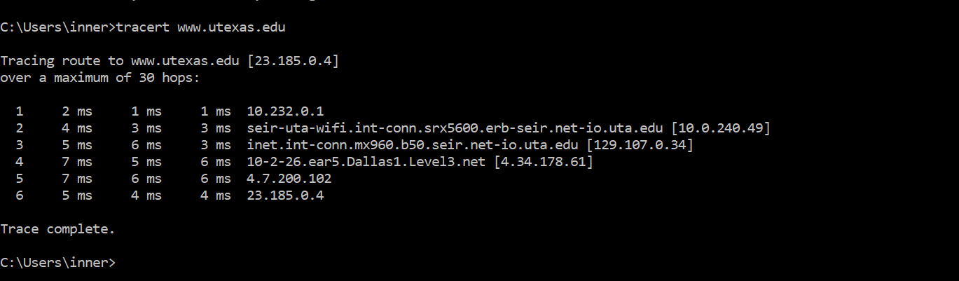
a) What kind of box (generically) is that first tracert response from? (e.g., is it a
switch?)
The first response, 10.232.0.1, is from my default gateway. The default gateway is basically the local router. This is the device that sits between my computer and the rest of the network. This is the same whether I’m at home or at the university. It gets my data from the local network to the broader internet.
b) What did you learn from this test that you did not learn from the ping?
Save your text file to disk.
Ping just tells me if the destination is reachable and how long it takes to hear back. Traceroute goes further by showing the entire path my data takes to get there. It lists each hop along the way, starting from my local router, then passing through several UT Arlington systems, and eventually going through outside networks like Level3 before reaching the UT Austin server. This helps me understand not just whether the network is working, but also how it's working and where any slowdowns or issues might be happening.
5. In the CMD window enter the following:
tracert www.hostuk.org
Record the results in your text file (you can use screen shot).
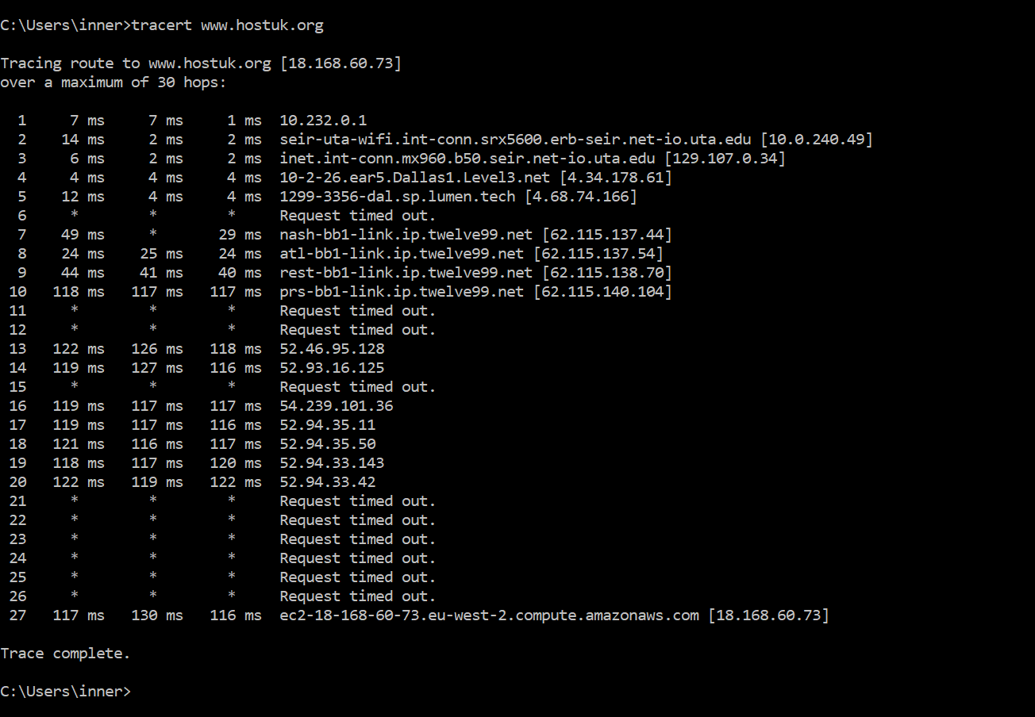
a) What do you think is making the sudden time increase at one hop (using the
average to compare)?
The big jump in response time happens around hop 10, where the average delay suddenly hits about 118 ms compared to earlier hops that were all under 10 ms. This is most likely the point where my data leaves the US and crosses into another continent, probably Europe, since the final server is hosted in an AWS region labeled “eu-west-2”, which is based in the UK. The increase in time could be caused by the long physical distance, or it might be due to things like network congestion, more complex routing, or even ISP-level traffic management.
b) Calculate the average RTT to www.hostuk.org.
Save your text file to disk.
At the final destination (hop 27), the times are:
117 ms 130ms 116 ms
So add all of them / 3 = 363/3 = 121 ms (Milliseconds)
6. Go to http://whois.arin.net/ui and enter 129.107.12.27 in the query field (upper right
corner). Click submit query button. Answer the following question based on the query
results.
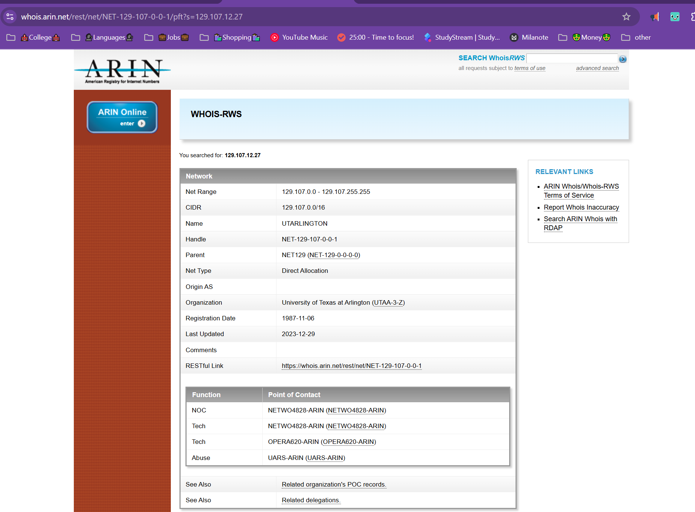
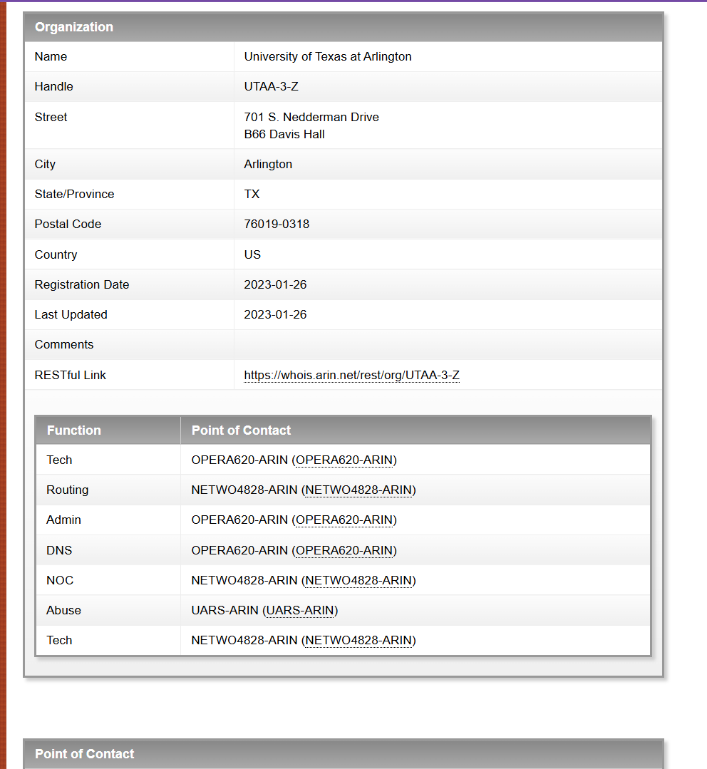
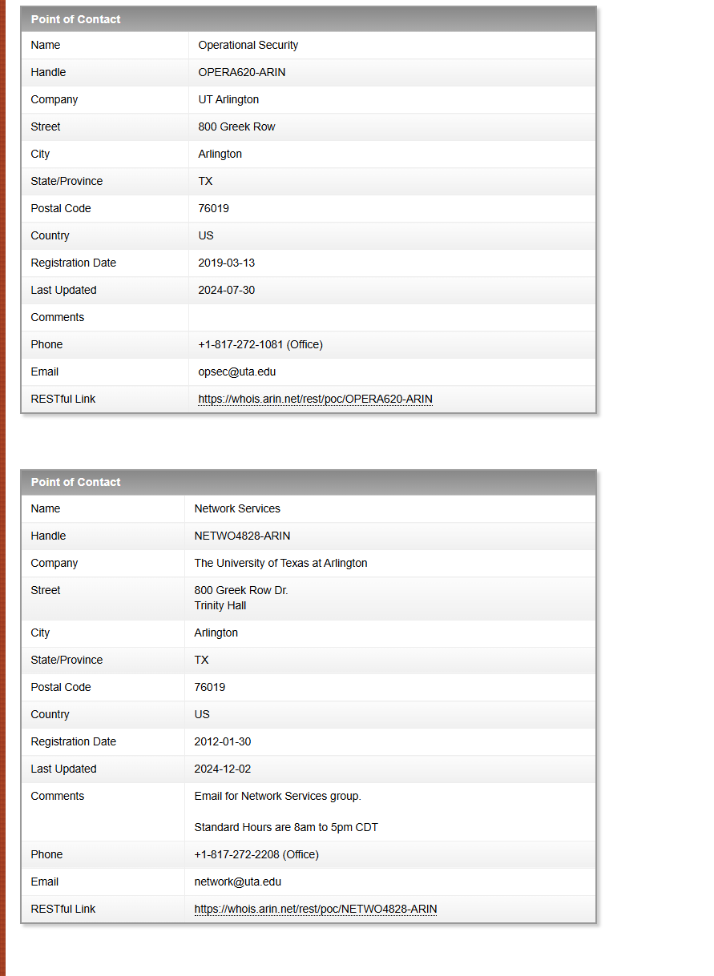
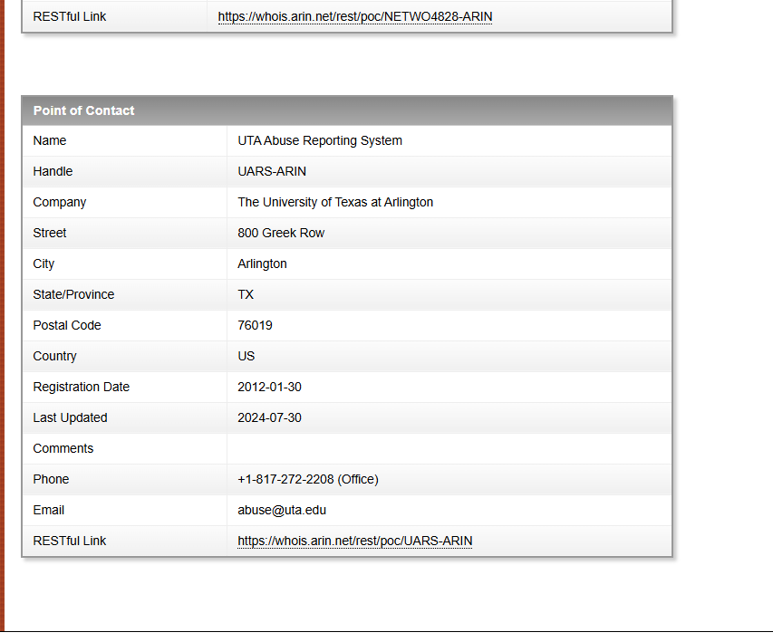
▪ Who owns this IP address?
University of Texas at Arlington- The organization name listed under the WHOIS record for IP 129.107.12.27 is "University of Texas at Arlington (UTAA-3-Z)."
▪ How many addresses does this organization own?
Save your text file to disk.
65,536 IP addresses- This is from CIDR block shown: 129.107.0.0/16. That number is 2^16 which equals to 65,536 IP addresses in that range.
7. Open Wireshark on your computer. Make sure you are capturing traffic on the active
network interface. Open your browser and visit http://neverssl.com. Capture content
of related http messages (request and responses).
Now, visit https://google.com and capture the content of related http messages. If you cannot capture related http message, explain why in your file.
Save your text file to disk.
(NOTE: Went back to my apartment because I knew that Wireshark was going to go crazy if I recorded data from the university WIFI).
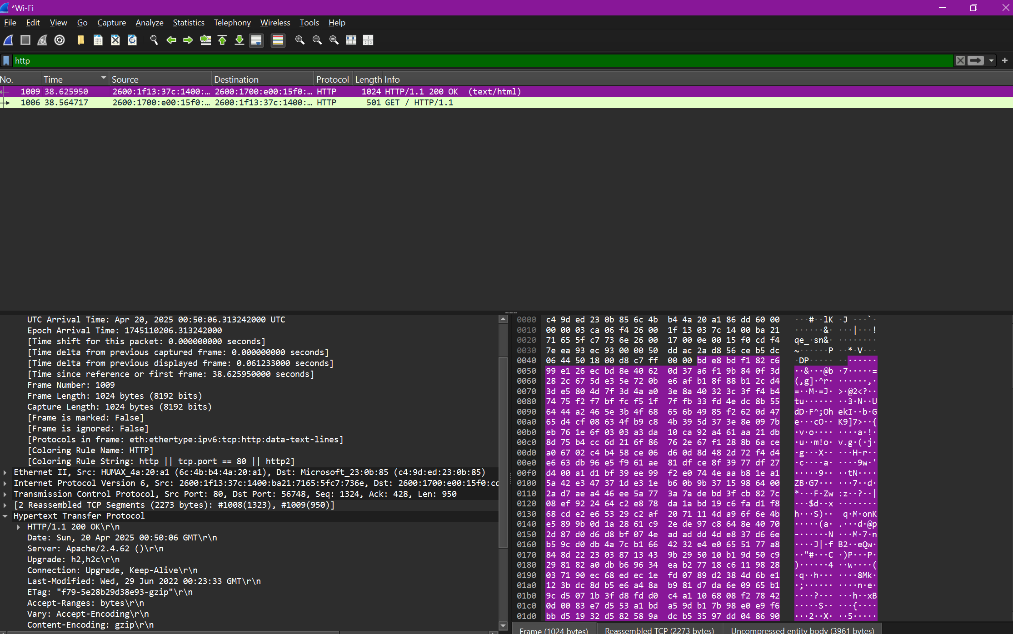
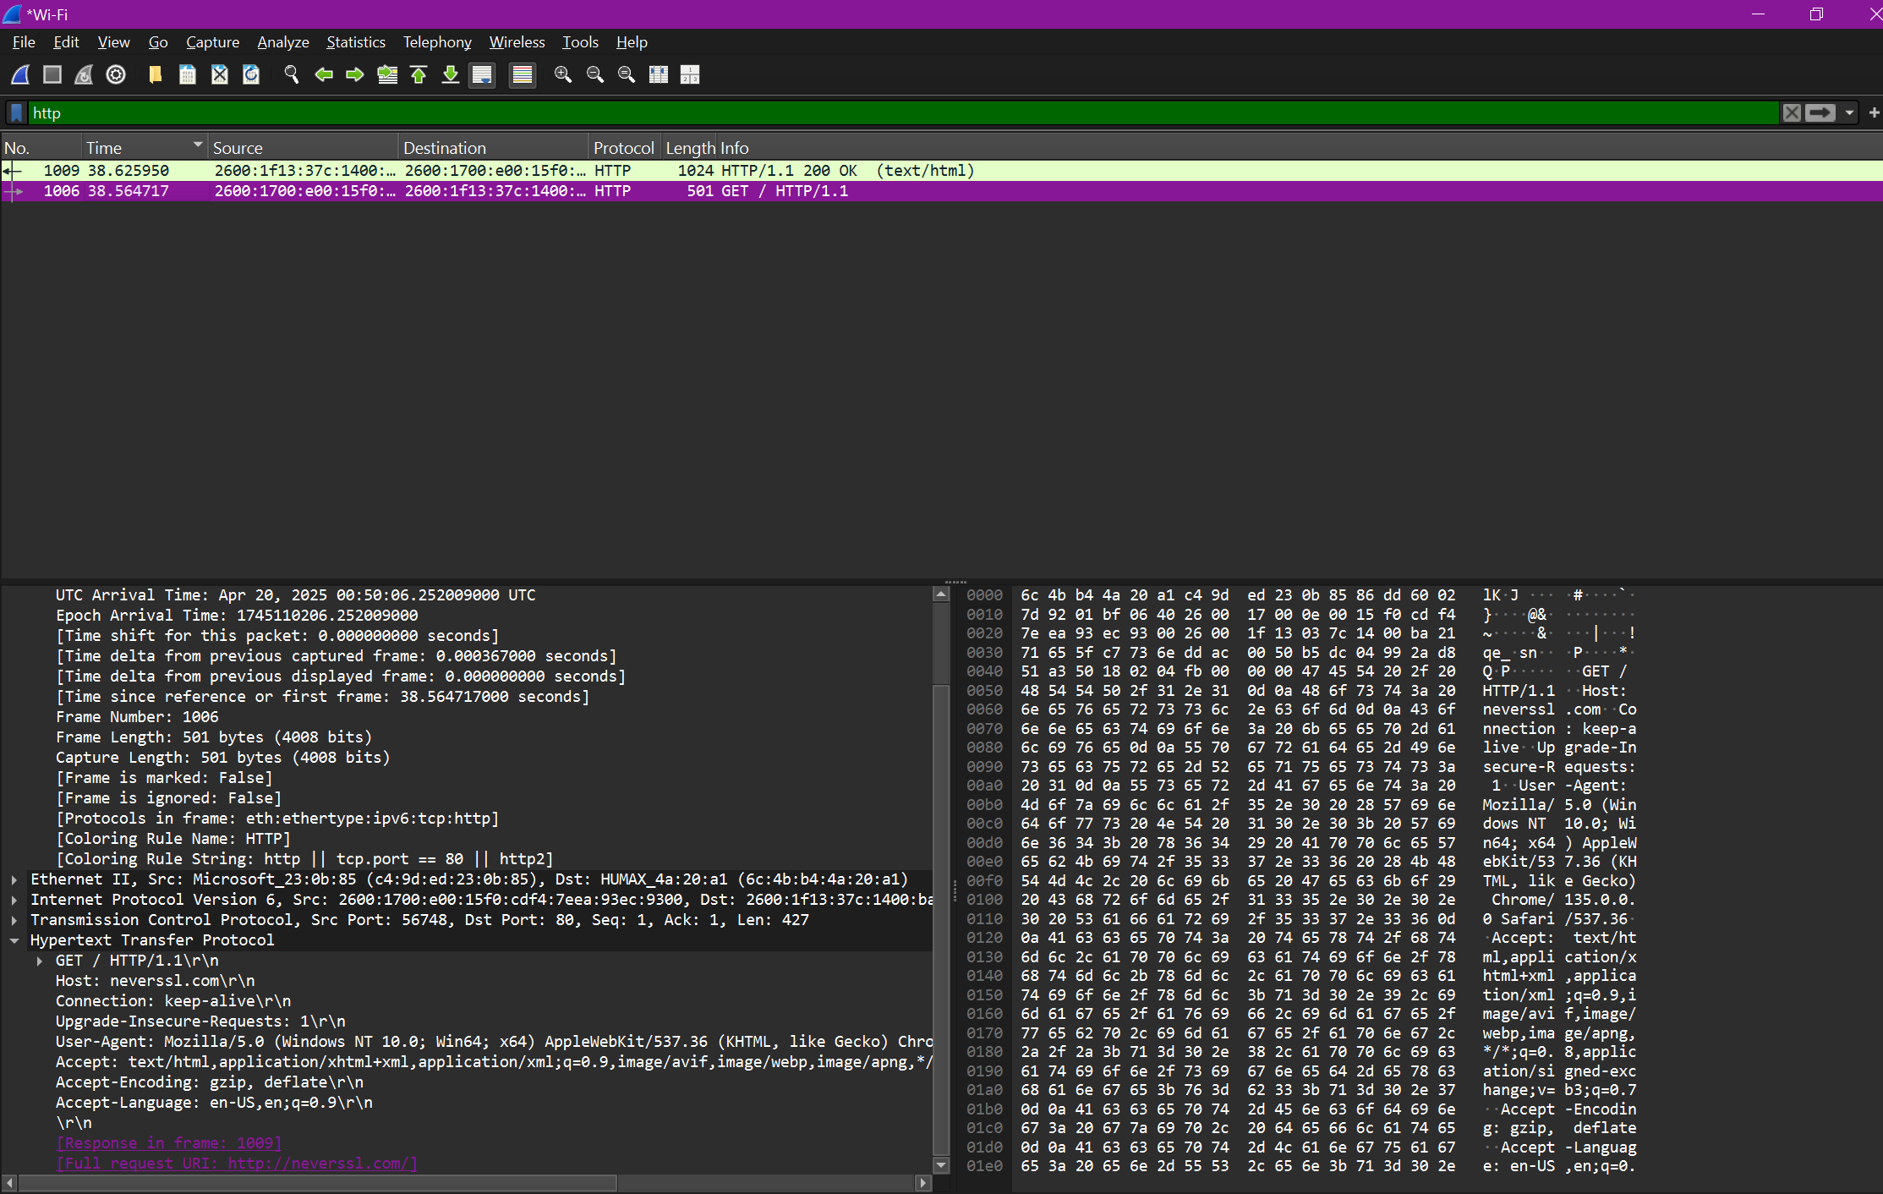
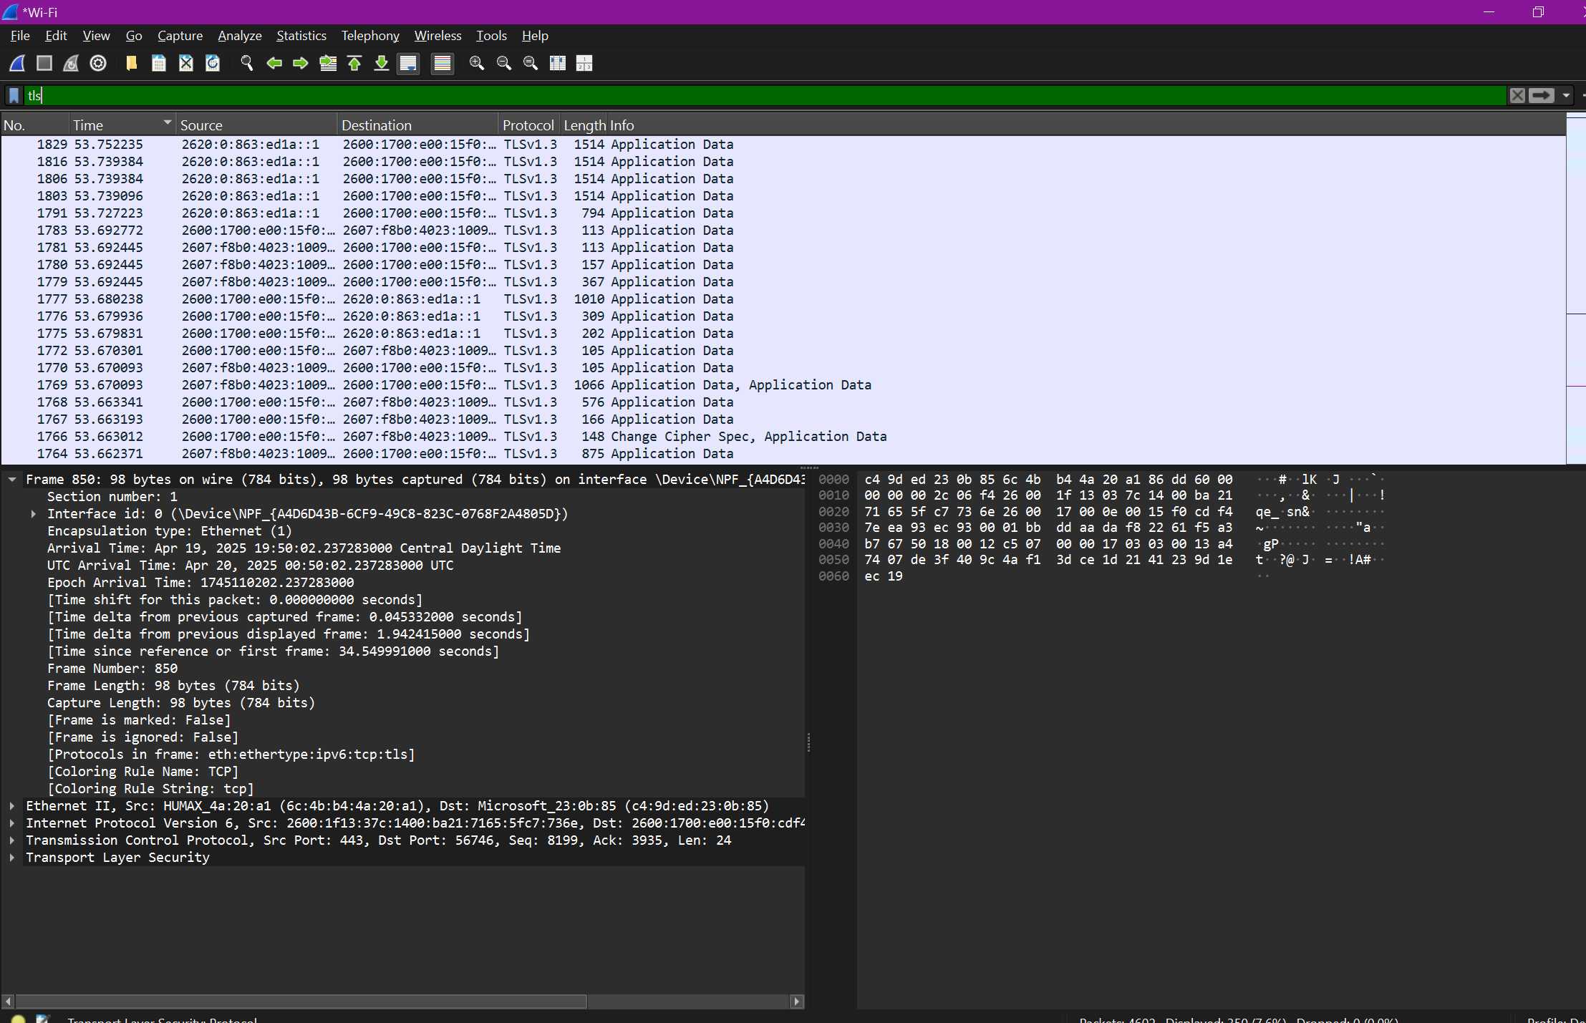
I ran Wireshark on my personal Wi-Fi because I figured trying to do this on campus internet would’ve flooded the capture with unrelated traffic (and probably gotten blocked or throttled anyway).
While capturing on my active Wi-Fi interface, I visited http://neverssl.com. Since it’s an unencrypted site, I was able to see both the HTTP GET request and the HTTP 200 OK response directly in Wireshark. The request showed typical browser headers like Host, User-Agent, and Accept, and the response came back in plain text (HTML format). I expanded the Hypertext Transfer Protocol section to show all the readable content clearly in the screenshot.
After that, I visited https://google.com. As expected, none of the actual HTTP content was visible in Wireshark. The only thing I could see were Application Data and TLSv1.3 handshake packets, which are both encrypted. This makes sense because HTTPS is supposed to hide all the request/response details to protect privacy. So yeah, unlike with neverssl, I couldn't see anything human-readable from Google because of the encryption layer.
8. Open your web browser, go to google.com and search “what is my ip address”. Take
a screen shot of your public IP address and save to you text file.
Determine if this IP as shown by google is your private IP address or public IP
address.
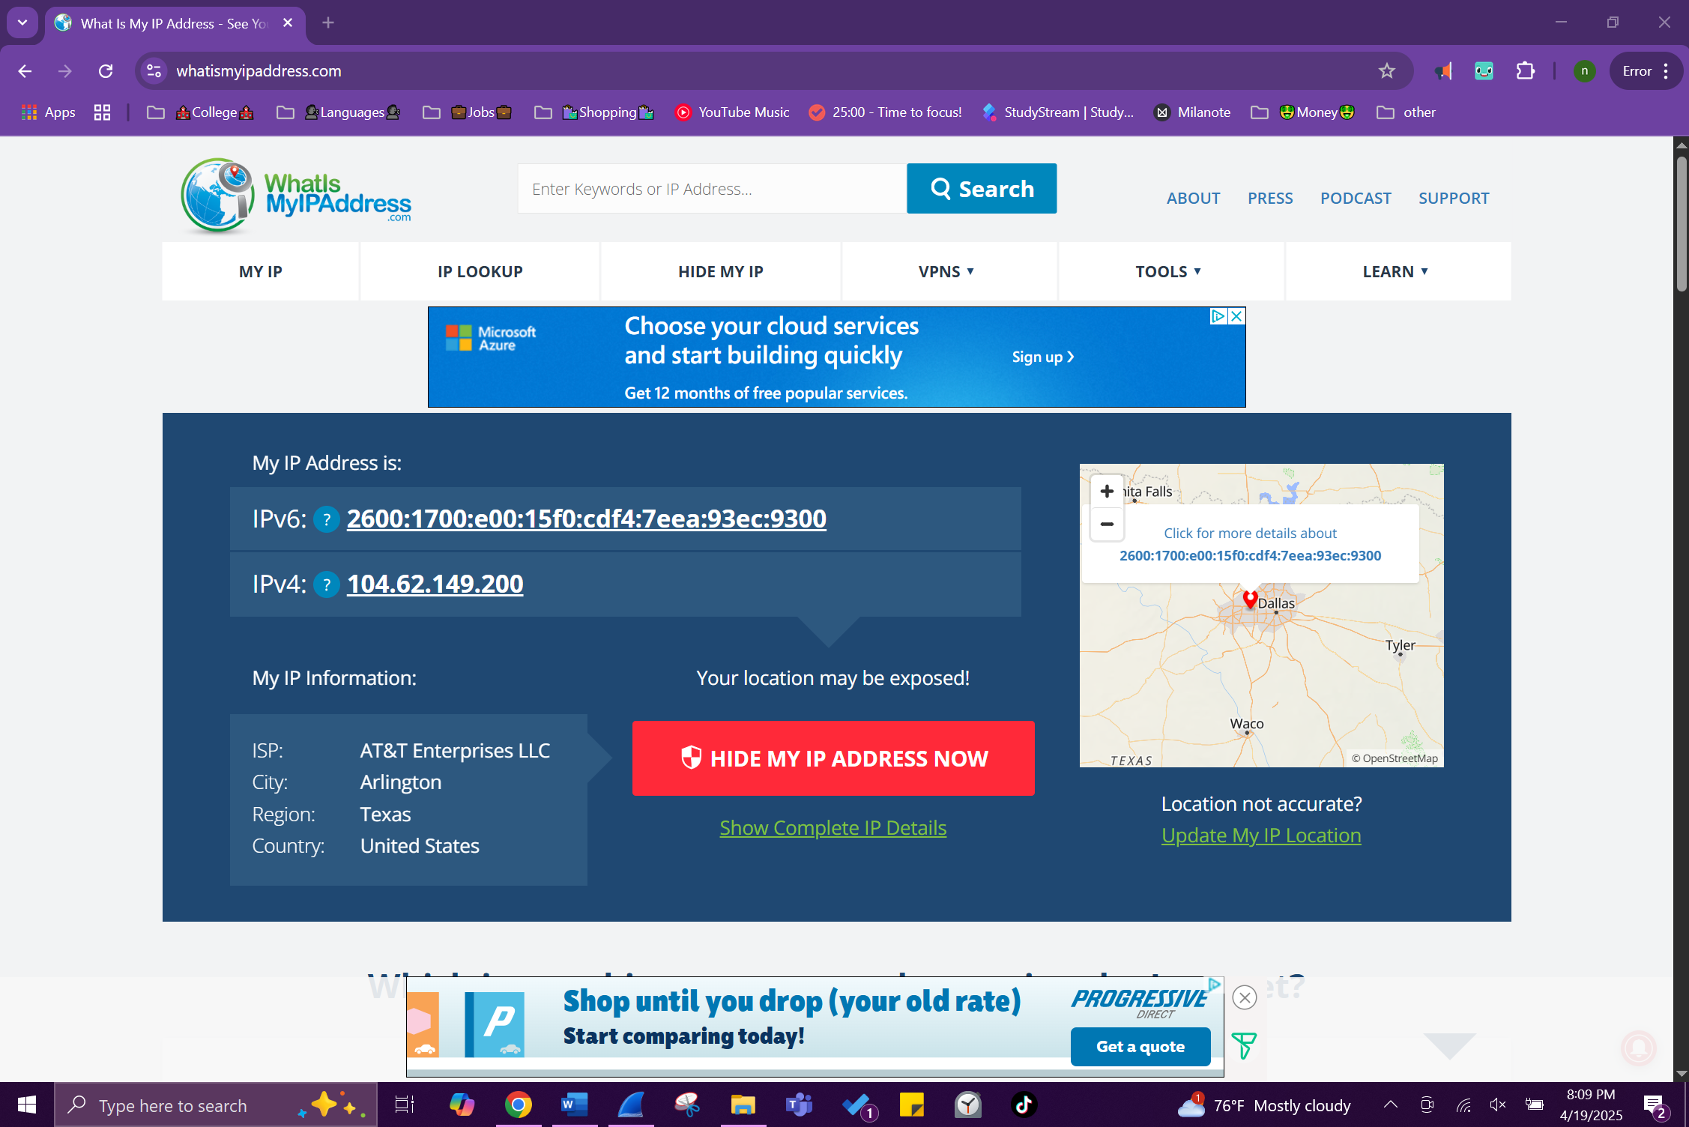
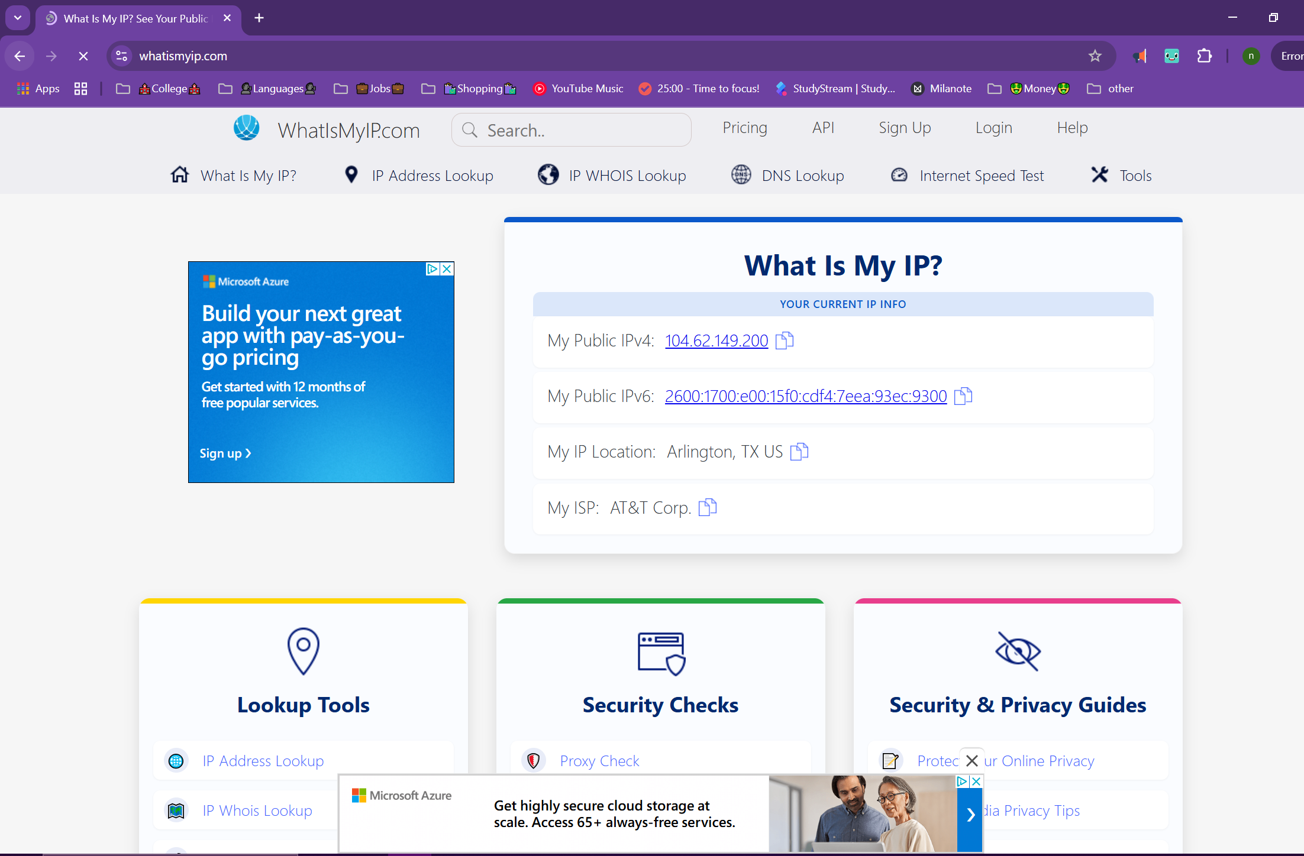
The IP address shown on the site (104.62.149.200) is my public IP address. This is the one that’s assigned by my internet provider, AT&T, and it’s what websites and services on the internet see when I connect to them. It’s totally different from the private IP I see when I run ipconfig on my laptop, because that one is just used inside my own network. Private IPs usually start with something like 192.168 or 10.x.x.x and don’t leave my local Wi-Fi. My router’s job is to take my private IP and swap it out with this public IP whenever I go online. So even though I’ve got a private IP on my laptop, everything I do on the internet goes through this public one.
Write up:
Your text/word/pdf file will be your writeup.
Submission:
Submit through Canvas and make sure to include your name and ID in your file name.
Important Note:
The same rules about collusion and plagiarism apply as with lab 1 except
that you will not be submitting program code with this lab

